**Exhaustive Analysis of Indian Agriculture using PowerBI**

**Step 1**: Open PowerBI

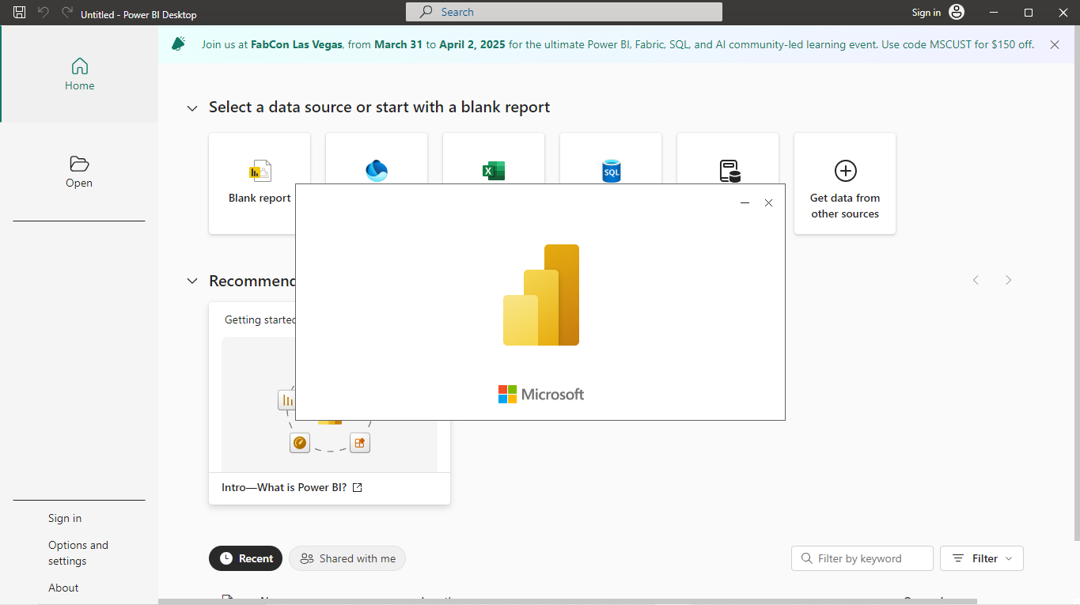

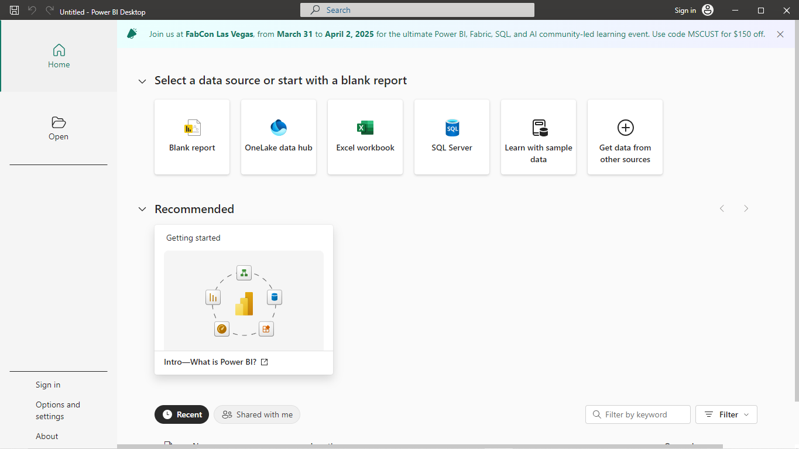**Step 2**: The welcome window appears on the screen.

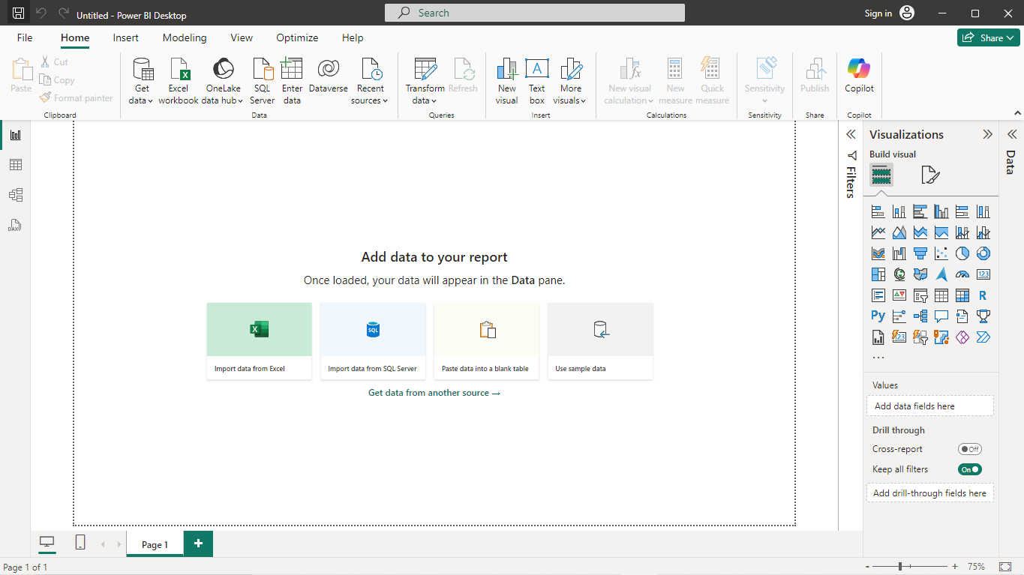**Step 3**: This page appears and it is called PowerBI Desktop. This desktop contains certain charts and visualization on its right-side and is known as Canvas.

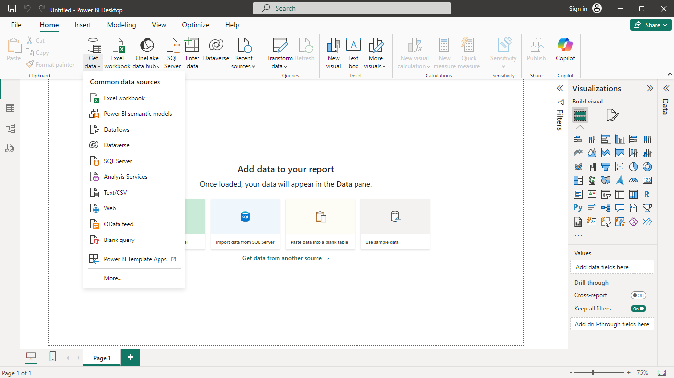**Step 4**: Use Get Data option to extract the the data into the canvas,this option contains many types of source file formats that specifies the data set format.

**Step 5**: select the dataset file format and upload the dataset file to work on it in the created canvas.

Click on Test/Csv to upload our CSV file (data set) into the canvas and select the file.



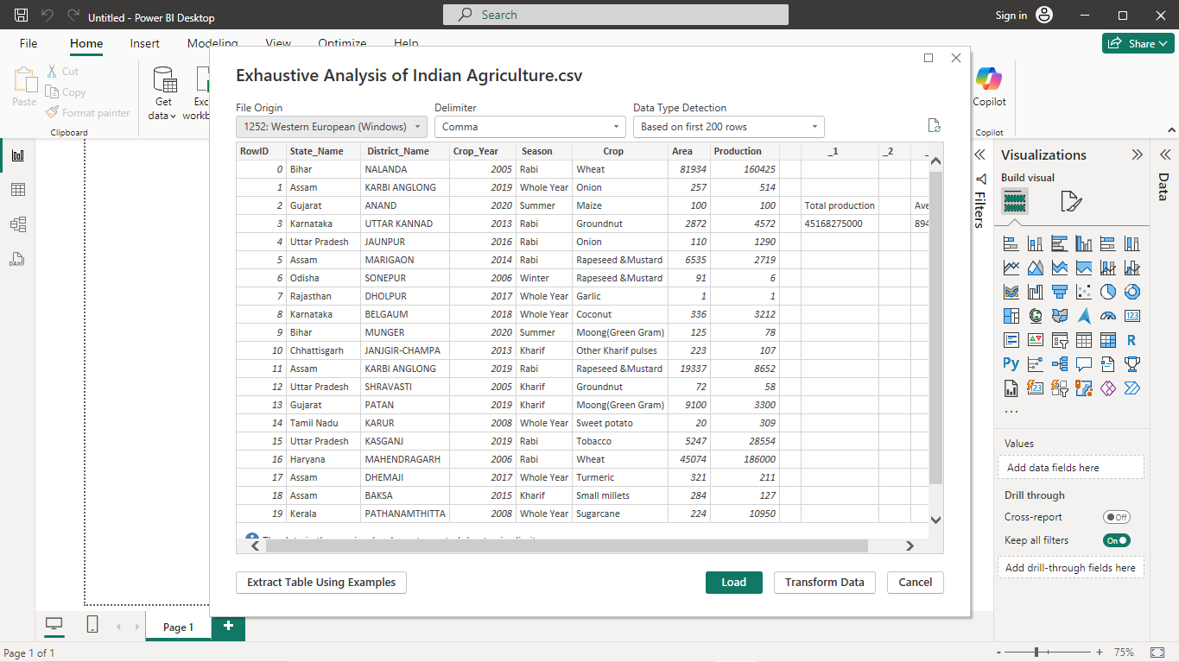**Step 6**: This is the overview page of the data set that is loaded in the canvas. Click load button at the bottom of the overview page to load data into canvas.

The data gets processed when transform data command is clicked.

It loads the Data when the data in the dataset is clean.

**Step 7**: To clean raw Dataset, click on the transform data button.

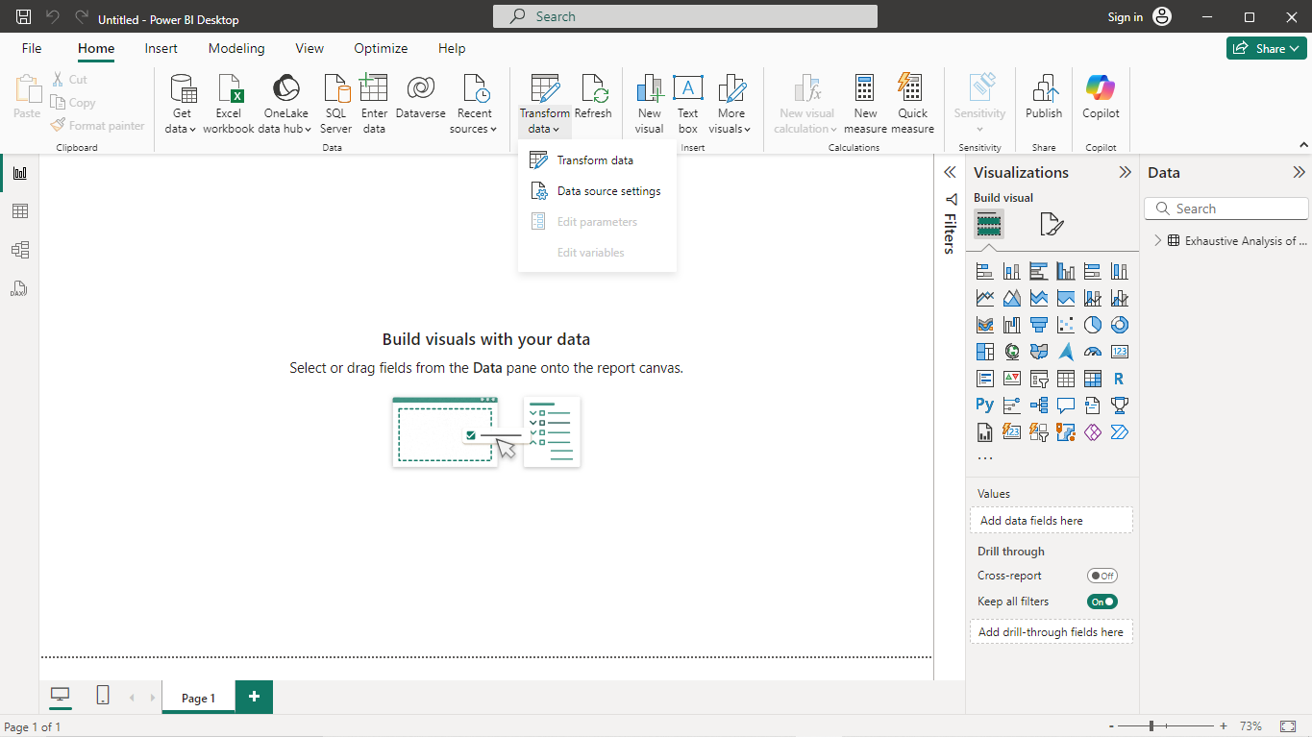

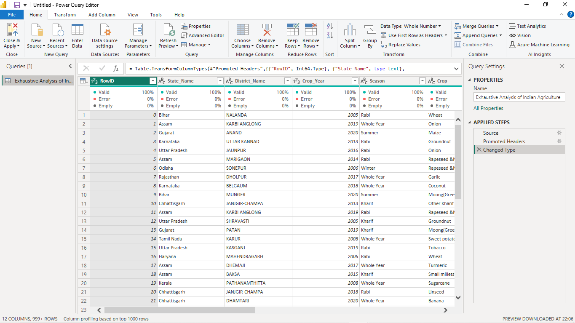**Step 8**: A New window appears in the screen, which is known as Power query editor that allows users to perform all transformation of data’s in the dataset. It contains many buttons such as keep rows, remove column, enter data, replace values etc.… to work on the dataset.

**Step 9**: Click on remove to remove the column. Now observe the applied steps pop-up box where all the transformations gets stored. These stored transformations can be retrieve by selecting it on the applied steps pop-up box.

Click on remove to remove the column.

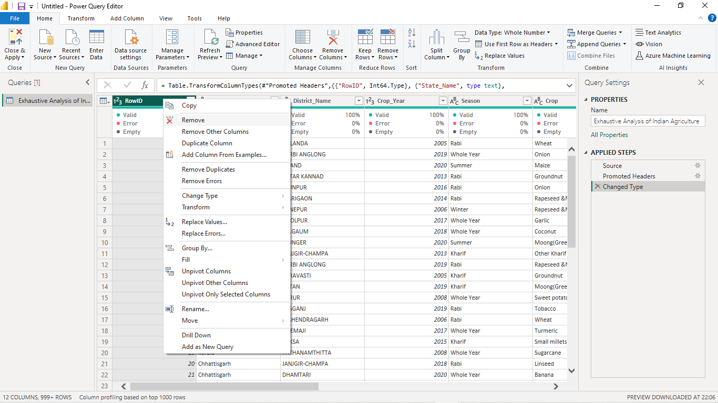

**Step 10**: Repeat the above steps and right click on the empty/unwanted column and click remove to remove it and clean dataset.

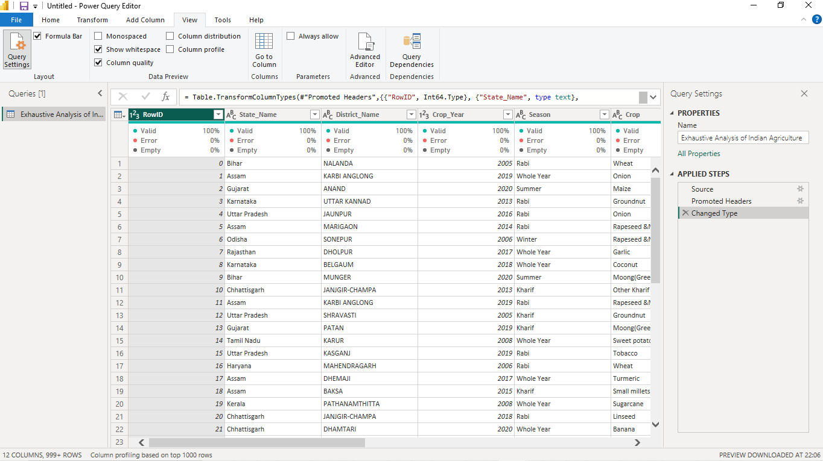**Step 11**: To check errors, empty spaces and validity of the dataset, go to view tab and click column quality.

**Step 12**: Click close and apply button from the home tab to save and apply changes in the canvas.

